# CONTENT

* Introduction
* Objective of the project
* Technologies & Resources required
* Screenshots
* Conclusion
* Scope

## 

## Introduction

Chronic kidney disease (CKD) means your kidneys are damaged and can’t filter blood the way they should. The disease is called “chronic” because the damage to your kidneys happens slowly over a long period of time. This damage can cause wastes to build up in your body. CKD can also cause other health problems.

The kidneys’ main job is to filter extra water and wastes out of your blood to make urine. To keep your body working properly, the kidneys balance the salts and minerals—such as calcium, phosphorus, sodium, and potassium—that circulate in the blood. Your kidneys also make hormones that help control blood pressure, make red blood cells, and keep your bones strong.

Kidney disease often can get worse over time and may lead to kidney failure. If your kidneys fail, you will need dialysis or a kidney transplant to maintain your health.

The sooner you know you have kidney disease, the sooner you can make changes to protect your kidneys.

## 

## Objective

The aim of this experiment was to determine the occurence of chronic kidney disease in the patient . Because the detection of the ckd (chronic kidney disease) is very difficult. Diffculty comes because the detection depends on a number of parameters. Also it will detect which parameter is more dependent .However, it predicts the disease 98 % .

## Technologies & Resources Required

#### Numpy :

NumPy is a library for the Python programming language, adding support for large, multi-dimensional arrays and matrices, along with a large collection of high-level mathematical functions to operate on these arrays.

import numpy

#### Pandas:

In computer programming, pandas is a software library written for the Python programming language for data manipulation and analysis. In particular, it offers data structures and operations for manipulating numerical tables and time series. It is free software released under the three-clause BSD license.

import pandas

#### Label Encoder:

This approach is very simple and it involves converting each value in a column to a number. Consider a dataset of bridges having a column names bridge-types having below values. Though there will be many more columns in the dataset, to understand label-encoding, we will focus on one categorical column only.

from sklearn.preprocessing import LabelEncoder

#### Matplotlib:

Matplotlib is a plotting library for the Python programming language and its numerical mathematics extension NumPy. It provides an object-oriented API for embedding plots into applications using general-purpose GUI toolkits like Tkinter, wxPython, Qt, or GTK+.

#### Node-red:

Node-RED is a flow-based development tool for visual programming developed originally by IBM for wiring together hardware devices, APIs and online services as part of the Internet of Things. Node-RED provides a web browser-based flow editor, which can be used to create JavaScript functions.

#### IBM Watson Studio:

IBM Watson® Studio helps data scientists and analysts prepare data and [build models](https://dataplatform.cloud.ibm.com/docs/content/wsj/getting-started/welcome-main.html?audience=wdp&context=wdp) at scale across any cloud. With its open, flexible multicloud architecture, Watson Studio provides capabilities that empower businesses to simplify enterprise data science and AI.

#### IBM Machine Learning:

IBM Watson® Machine Learning helps data scientists and developers accelerate AI and machine-learning deployment. With its open, extensible model operation, Watson Machine Learning helps businesses simplify and harness AI at scale across any cloud.

## Screenshots

**Dataset:**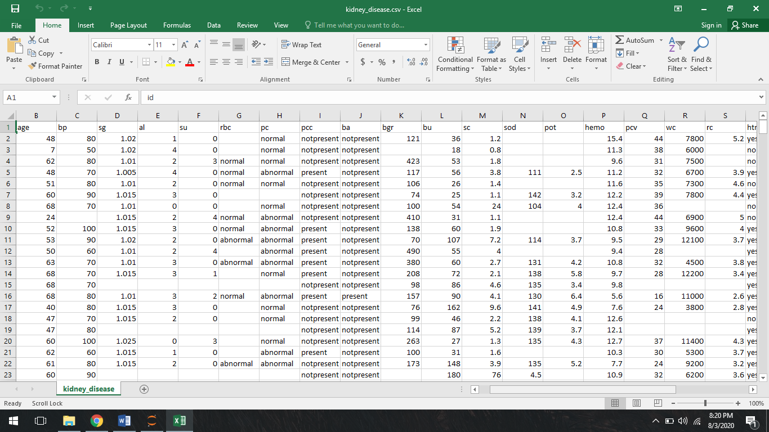

**Cleaned dataset:**

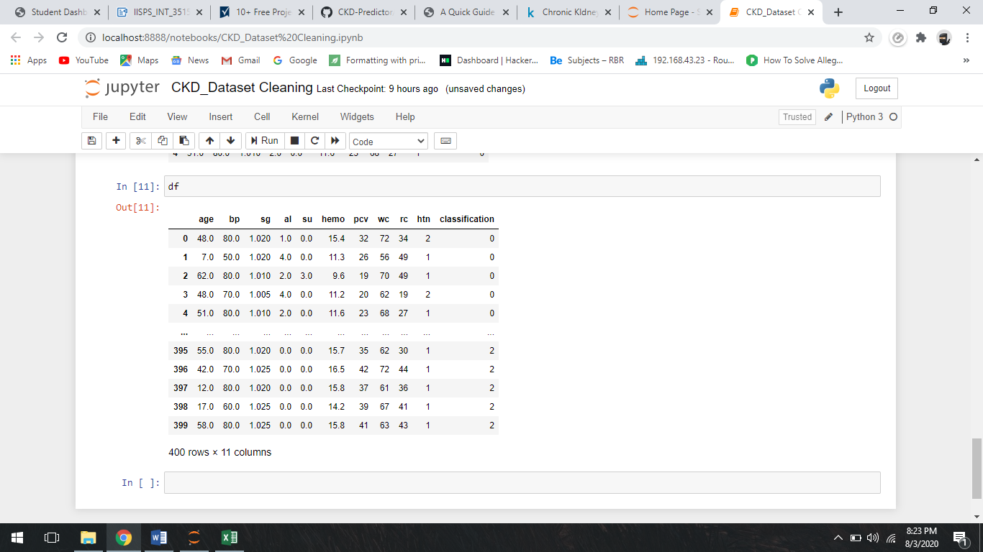

**Services Of Watson studio & Machine Learning:**

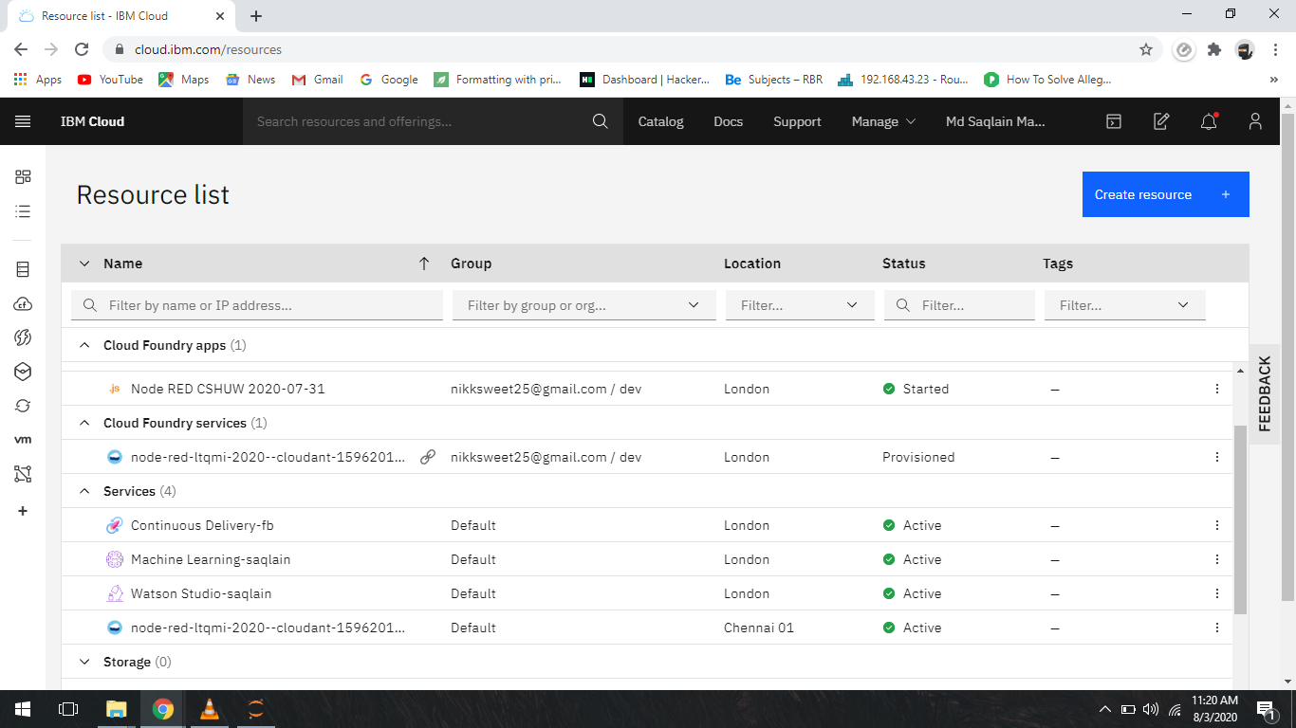

**Deployment of CKD model:**

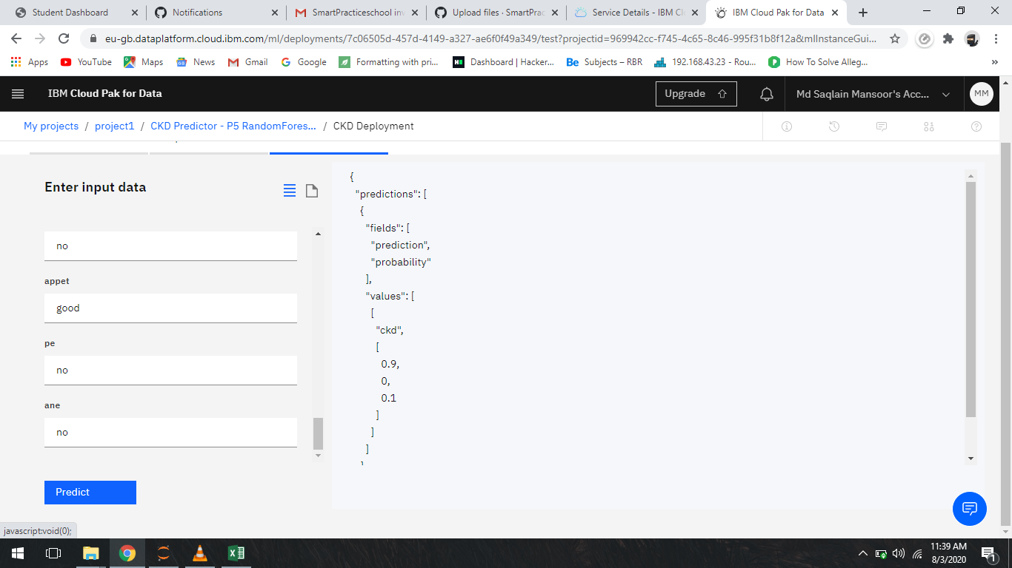

**Node-red Flows:**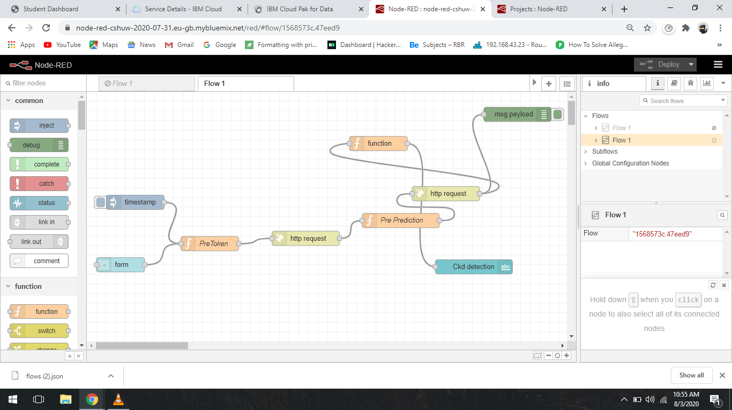

**Node-red UI:**

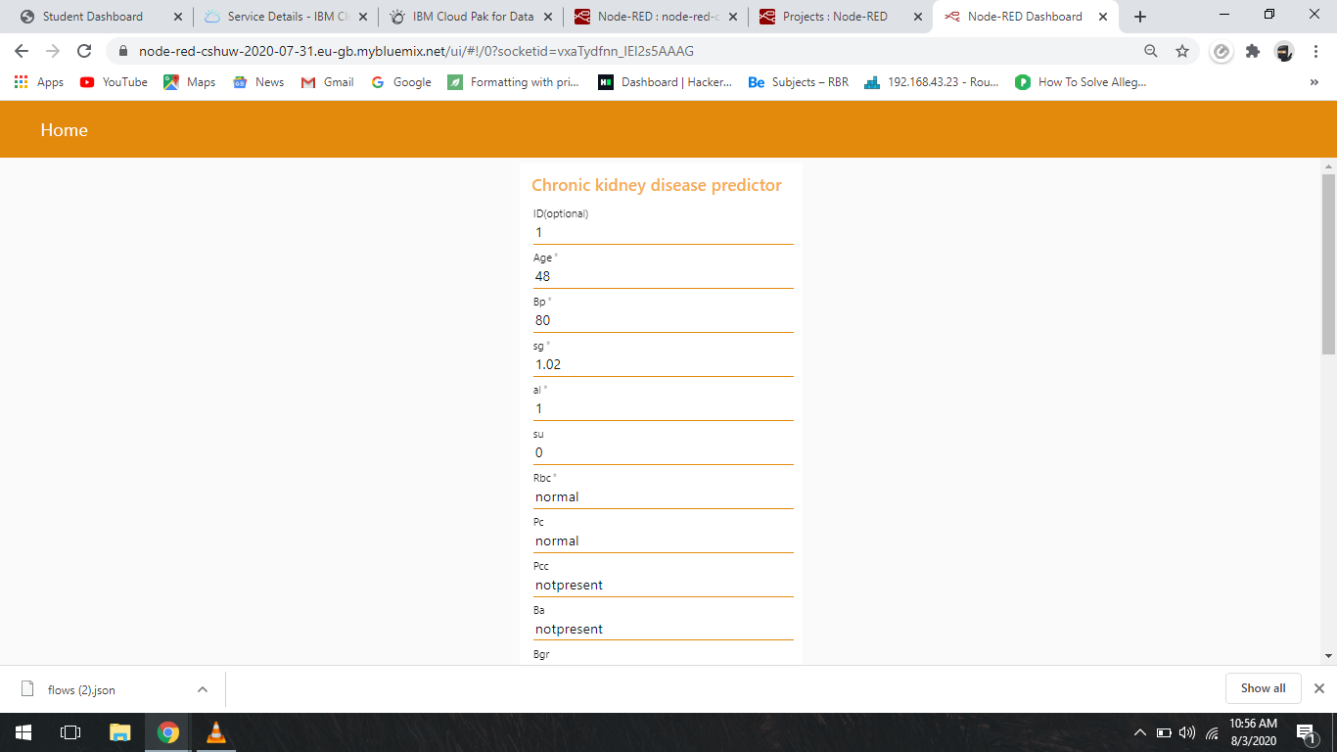

## Conclusion

Chronic kidney disease (CKD) means your kidneys are damaged and can’t filter blood the way they should. The disease is called “chronic” because the damage to your kidneys happens slowly over a long period of time. This damage can cause wastes to build up in your body. CKD can also cause other health problems.

The model we built helps in determining or detecting the occurence of Chronic kidney diseases by considering the data that can affects its occurence . And also the results get more affected by the red blood cell, white blodd cells, blood pressure, pcv etc. So data of the patients health plays a key role. And that data we use to evaluate the occurence of CKD .

**Scope**

The machine learning and artificial intelligence help to build the various prediction and detection models . One of them is what we have practically practiced and created, that is Chronic kidney disease predictor. The goal was to create a model which will detect the ckd by just taking some parameters of patient's health. It requires very less time and its costless as every resources are available for free and are open source. Also maintainence is easy.